## Demo: Azure Traffic Manager

Azure Traffic Manager allows you to control the distribution of user traffic to your specified endpoints, which can include Azure hosted web sites, Azure web apps, and other endpoints.

It is configured using a collection of settings called a Traffic Manager profile. In ARM, each Traffic Manager profile is represented by an ARM resource, of type ‘TrafficManagerProfiles’, managed by the ‘Microsoft.Network’ resource provider. Azure Traffic Manager gives you three traffic routing methods to choose from: [failover, performance, or weighted round robin](https://azure.microsoft.com/en-us/documentation/articles/traffic-manager-load-balancing-methods/). In this demo we will implement the ‘Priority’ method (formerly known as failover).

### Staging Instructions

* Create two Azure Web Apps in two different regions.
* Create a Traffic Manager ‘failover’ Profile
* Add Azure end points for the web applications created in step 1 to the profile
* Set and enable the profile

#### Task 1: Provision web servers in two regions.

1. Create a new Windows Server 2012 R2 virtual machine.

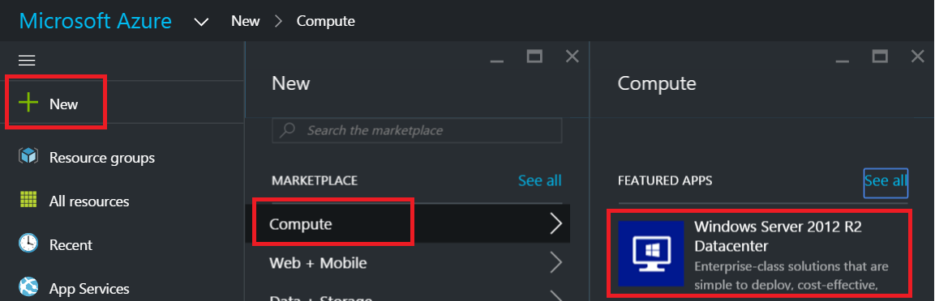

1. Choose the “Resource Manager” deployment model and click “Create”.

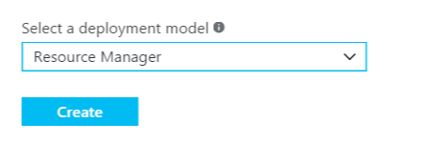

1. For the virtual machine provide the following configuration:
   * Name: **WebApp1**
   * User name: **demouser**
   * Password: **demo@pass123**
   * Subscription: **choose your Azure subscription.**
   * Resource Group: **Create a new resource group called WebApp1RG.**
   * Location: **choose the closest region to you.**
2. For the size of the virtual machine select **Standard D1.**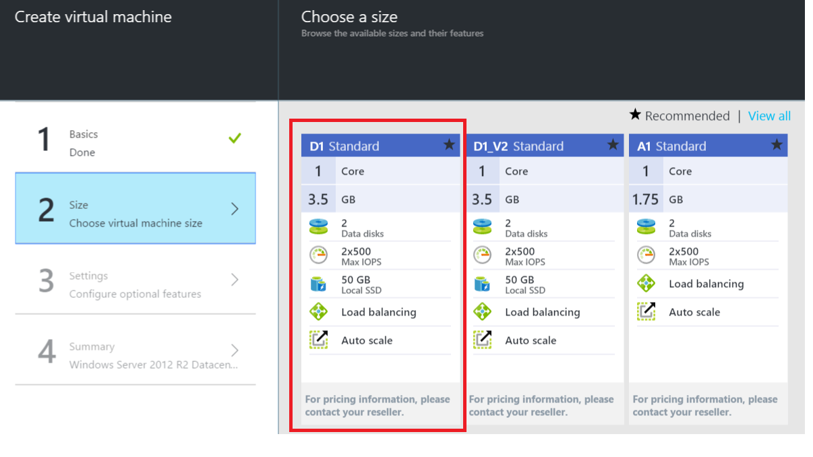
3. In the settings section, ensure **Standard** storage is selected, click **Network Security Group**, and then click **Add an inbound rule**.  
   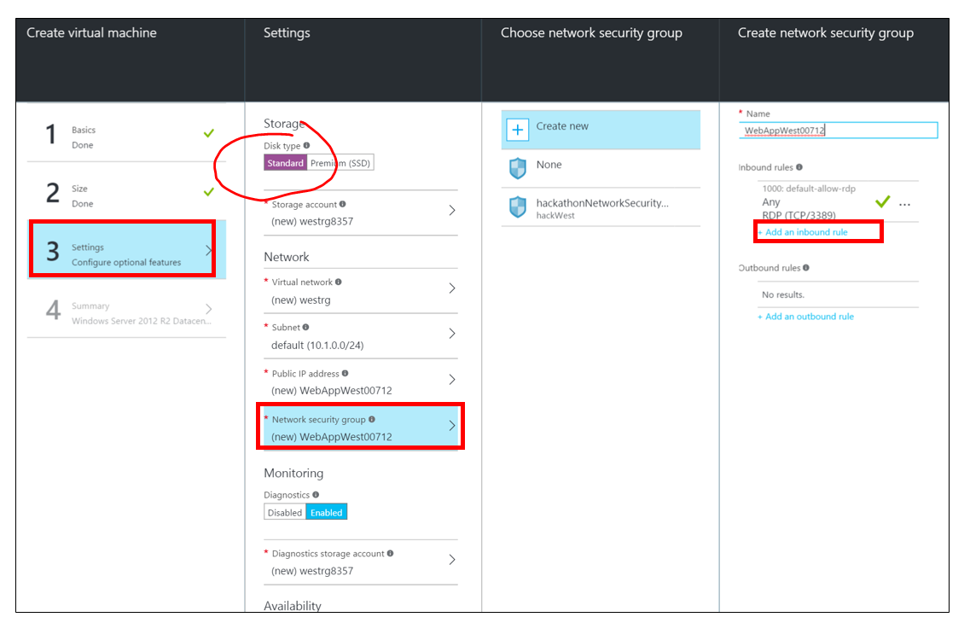
4. Add an inbound rule as below:

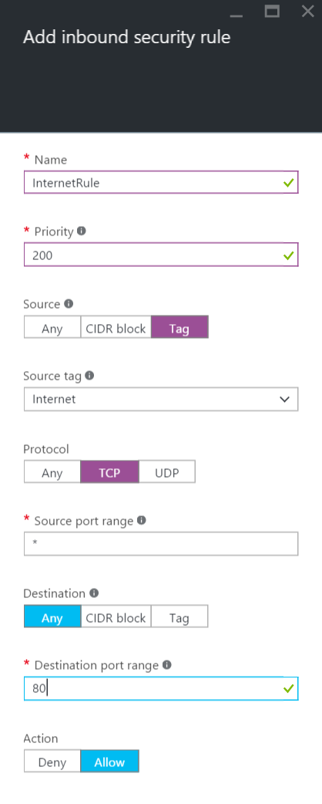

1. Click all **OK** buttons and create the virtual machine.
2. Repeat the previous steps to create a **second** virtual machine and provide the following configuration

* Name: **WebApp2**
* User name: **demouser**
* Password: **demo@pass123**
* Subscription: **Choose a relevant one.**
* Resource Group: **Create a new resource group called WebApp2RG.**
* Location: **Specify a different region from the first.**

1. At this point, you should have two Windows 2012 R2 Servers in two different regions.

#### Task 2: Add IIS role to the Windows Servers

1. After each virtual machine is provisioned login using remote desktop by clicking the Connect button on the virtual machine configuration blade and logging in with the administrative credentials.
2. Once inside the VM, click the PowerShell icon on the task bar.
3. In the PowerShell console execute the following command to install IIS:

Add-WindowsFeature -Name "Web-Server"

1. Repeat the steps for both virtual machines to install IIS.
2. After Once IIS has completed installation open the file C:\InetPub\wwwroot\iisstart.htm in notepad on each server. Below the div with the id of container add the region name the server is located in and an HTML break <br /> (example below). Save both files.

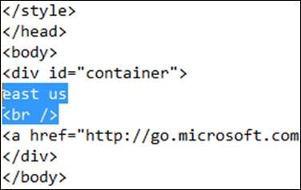 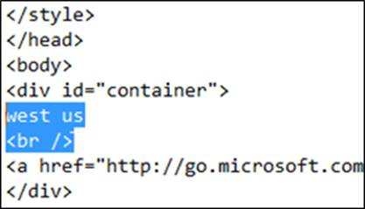

NOTE: To make this easier to see for the students, you may want to do one of the following options:

<font size=”7”>EAST US EAST US EAST US EAST US</font>

<H1>EAST US EAST US EAST US EAST US</H1>

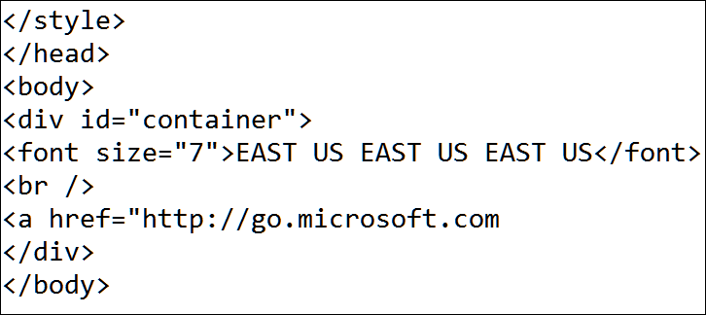 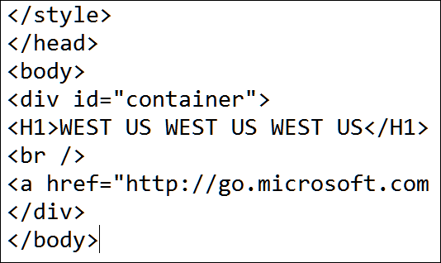

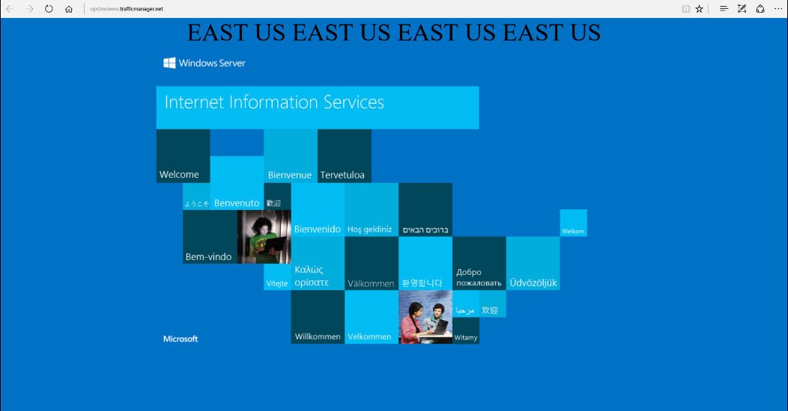

#### Task 3: Configure DNS Labs on the Web Server Public IPs

1. In the Azure Management Portal click **Browse** -> **Resource Groups** and select **WebApp1RG**.
2. Click the Public IP resource **WebApp1**.



1. Click **Configuration** and specify a unique DNS name label and click **Save** on the toolbar.

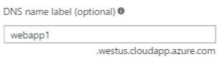

1. Repeat the steps and open WebApp2RG, then set a unique DNS name on the WebApp2 public IP.

#### Task 4: Configure Traffic Manager

1. In the Azure Management Portal click **Browse** -> **Traffic Manager Profiles**
2. Click the Add button from the toolbar to create a new profile

|  |  |
| --- | --- |
|  | * Name: **A unique name for the Traffic Manager profile** * Routing method: **Priority** (this is formerly failover) * Resource Group: **ARMTMRG** * Location: **Choose the region closest to you** |

1. Click **Create** to create the Traffic Manager profile.
2. Change the Traffic Manager DNS TTL to 30 seconds (easier to validate a failover)

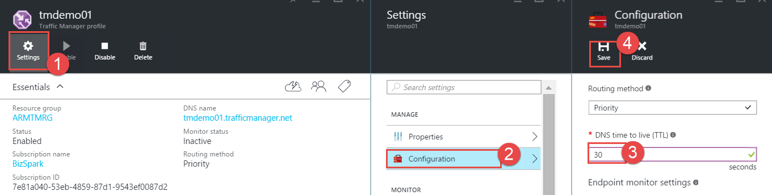

1. Click the **Endpoints** tile.

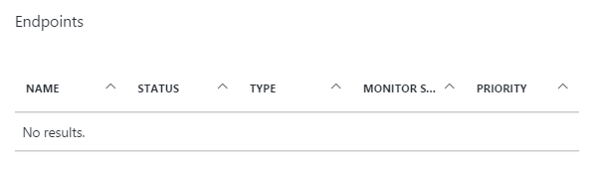

1. Click Add

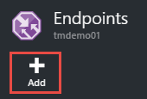

1. Add an endpoint to the Traffic Manager profile for the first virtual machine.

|  |  |
| --- | --- |
|  | * Name: **WebApp1** * Priority: **1** * Resource Group: **WebApp1RG** * Target resource type: **Public IP Address** * Target Resource: **WebApp1** |

1. Add another endpoint for the second virtual machine.

|  |  |
| --- | --- |
|  | * Name: **WebApp2** * Priority: **2** * Resource Group: **WebApp2RG** * Target resource type: **Public IP Address** * Target Resource: **WebApp2** |

### Traffic Manager Demo Instructions

1. Browse to <http://portal.azure.com> using your Microsoft ID. Navigate to the traffic manager blade.

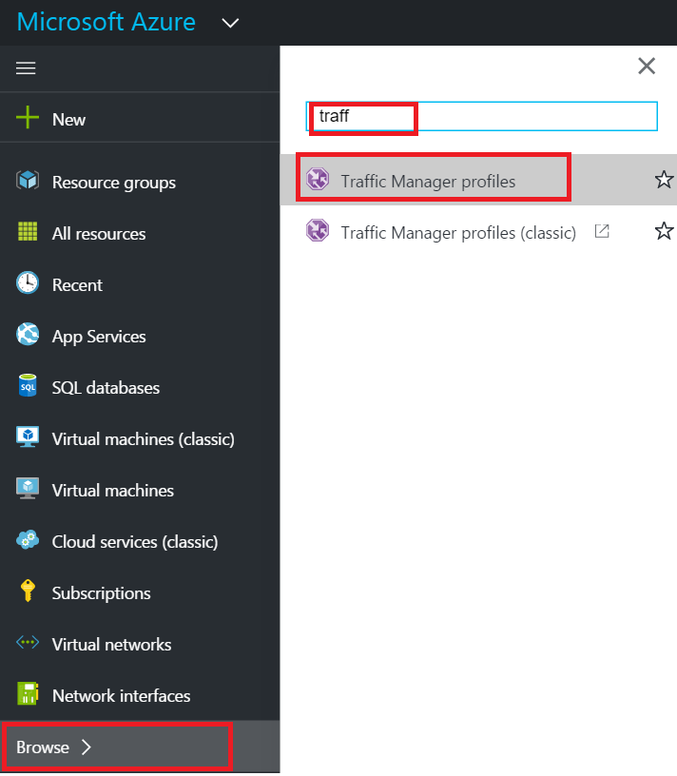

1. Click the Traffic Manager Profile name to open.
2. Observe that the two end points we added are reflected here. 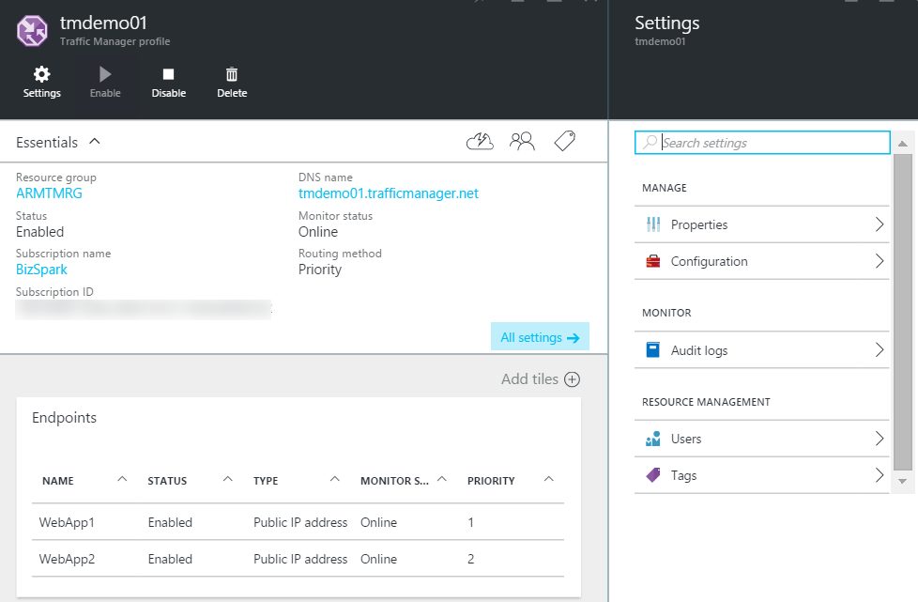
3. Click the DNS name to load the website through the Traffic Manager endpoint.
4. If you added west site before, then west site will come up because the traffic manager profile is ‘priority’ or in other words ‘failover’. Only when west site is unreachable for 30 seconds will the traffic manager switch to the Central site.
5. In the Portal, open the configuration blade for the WebApp1 virtual machine and click **Stop** on the toolbar.
6. Go back to the browser and refresh the Traffic Manager DNS profile URL. This should give you an error that the webpage is not available.
7. Wait for 30 seconds (since we had set the TTL for the traffic manager profile as 30 seconds), and refresh the browser again. Traffic Manager will display the webpage from the second region.